**Design Considerations and Key Takeaways for Modern Machine Learning Engineering and Infrastructure**

Suqiang(Jack) Song

https://www.linkedin.com/in/suqiang-song-72041716/

# Context

***What is Machine learning engineering ( MLE ) ?***

Machine learning engineering (MLE) is the use of scientific principles, tools, and techniques of machine learning and traditional software engineering to design and build complex computing systems. MLE encompasses all stages from data collection, to model training, to making the model available for use by the product or the customers.**[1]**

Machine learning engineering and infrastructure , typically described as a “platform” technology bearing artificial intelligence algorithms and lifecycle management, more and more attention has been paid to it and lots of industry leading and high tech companies are exploring or adopting it.

In this article, I will discuss a couple of design considerations and look into the technical details and key takeaways of modern machine learning engineering and infrastructure and we will call it the **MLE platform** in the future.

# 01 Efficient Programing Language

Python has become one of the top 3 programming languages in the world, on a par with C and Java ( TIOBE 2021 programing languages ranking **[2]**) , after a decade of rapid growth and popularity.  
  
In the AI world, Python has become the major industry standard.It deeply affects the foundemenal design of MLE platforms , there are two major considerations:

Code Running Environment

A big part of Python's popularity in AI is the diversity of its ecology, the variety of excellent third party libraries.AI itself is a rapidly developing field, different models and algorithms are developed by different research institutions, and different open source libraries are used in the source code of these algorithms and models. As a result, it is difficult for the industry to unify different projects into a standard software environment when commercializing these research results.

At the same time, many components, in order to solve the efficiency problems of interpreted languages such as Python, are often mixed with the C programming language. This mixture of managed code and unmanaged code increases the complexity of software environment management.Therefore, one of the top problems to be solved by MLE platform is the need to support project-level software environment isolation and life cycle management. A computing platform that only supports global configuration of software environments will be difficult to support the application of AI algorithms in multiple scenarios or lines of business in companies.The solutions to resolve environment isolation problems are mainly classified to three tiers, interaction tier, managed code tier and unmanaged code level.

Specifically, pure managed code applications can use Python library package management and virtual environment, such as Conda-pack, to dynamically download and automatically distribute the corresponding library package to each node, in order to achieve dynamic configuration of the running environment.

The limitation of this approach is that the underlying binary running environment and toolchain are shared. For such dependencies involving unmanaged code, a more complete environment isolation technology is required, and the most potential is K8S containerization technology.With containerization, the different dependencies involved in unmanaged code can be resolved using different images, and when the application is destroyed, the container is recycled without contaminating the environment on the physical/virtual nodes.

***So the takeaway of a modern MLE platform could be based on K8S containerization technology as a resource manager for the full life cycle management of applications.Beyond this, the platform should also support the library package management and automatic distribution of the upper-tier pure managed code to achieve lightweight environment isolation.***

Code Efficiency

In addition to the environment in which the software is run, the cost of running code is also heavily influenced by the programming language.

If applications and platforms are written in the same programming language, then the cost of interaction between the them is lowest.Computer science calls this the "native advantage of a Native Language."

However, We are losing this advantage in the AI world

* From data science perspective, business decisions are served by AI algorithms and models, with Python as the first language
* From AI lifecycle perspective, some of stages such as data processing, model serving and predictions are based on Java/Scala those JVM languages;
* The underlying computing power is heterogeneous resources, that is, we are in the era of CPU/GPU/FPGA/ASIC heterogeneous hardware as computing resources, and the native language for hardware is C/C++.

The above reality of the disunity between the first language of data science and the first language of other engineering and IT infrastructure made the one of the fundamental challenges for MLE platform , that is, how to make the AI application with the lowest cost, make the model written by Python a "first-class citizen", but achieve or approach the performance of the platform's native language.

The common practice is to use shared storage, that is, one process writes data to a storage such as HDFS or S3 compatible object storage , and another process reads data.The biggest problem with this is inefficient communication.

Cross-language communication is essentially inter-process communication (IPC), that is, the use of the same data in different languages (processes), so it is more efficient to implement data exchange at the memory level.In order to reduce the serialization and deserialization of data exchanged between processes, especially between different processes on the same physical node, the adoption of shared memory can significantly reduce the copy of the same data, which requires an shared memory format standard. We noted that the **Apache Arrow Columnar format standard** for distributed memory column storage has developed rapidly since the release of V1.0 in 2020, and has now reached V 6.0 [3] . By taking advantage of this common format standard and powerful implementations , the different software stacks/libraries , different languages, and different hardware devices ( CPU,GPU,ASIC AND FPGA) and their accelerators are maturing support for this standard, which will significantly improve the performance of AI applications.

How to make full use of the new hardware computing power to improve the execution speed is the high priority of a MLE platform to optimize.It is worth noting that the native driver and operator library of the underlying hardware are based on C/C++ language, and the ecology of many high-performance computing fields is based on CUDA and MPI programming paradigms. Therefore, considering the underlying computing engine is implemented by C/C++ , ***a takeaway from it , CPython binding with the upper level of Python programming API, will be more competitive than the JVM based computing engine through Py4J implementation of Python programming API.***

# 02 Fine-grained Scheduling

ML engineering is inseparable from data engineering, and the monitoring and effect evaluation of the model after it goes online also needs data engineering .Therefore, the interconnection between MLE platform and big data engineering platform is absolutely a key design focus.But the fact is, the MLE and BDE platforms have different resource scheduling islands as in lots of cases , due to the isolated process or organizations , the MLE and BDE couldn’t share components , tech stacks , pipelines and CI/CD processes.

As mentioned above, leveraging K8S containerization by the underlying resource scheduling platform can solve the problem of resource scheduling islands. However, from the perspective of process/thread-level computing scheduling, if the computing engine cannot allocate the computation process required for model modeling to the same node where the big data processing process is located as far as possible, serialization and deserialization cannot be avoided, still resulting in unnecessary data exchange.***Takeaway of it , there are three technical issues that need to be addressed***:

* ***First, the computing engine needs to support a data localization scheduling mechanism.*** For example , the implementation of this technology can be based on the Arrow project Plasma Object Store**[4]** mechanism, that is, by recording the data owner information, the system can view the data dependency graph (DAG) when allocating computing resources. Therefore, under the condition of ensuring the computing resources, the computing process is allocated to the node where the data processing process is located.
* Second, the memory sharing mechanism.Take the Arrow project for example, it has largely been resolved.By adopting the distributed Arrow architecture design, it is possible to create a memory cache for each node, ***so that the interprocess communication at that node uses zero copy[5] as much as possible.***
* ***Third, computational scheduling needs to support both stateful and stateless tasks***.Stateless tasks have a lot of practical experience. The scheduling, life cycle management and resource usage of stateful tasks are more complex than stateless tasks, but they are more common in the field of distributed ML and deep learning.

# 03 Distributed Training and Tuning

Fundamentally, you have two choices when it comes to training ML/deep learning models:

* Option 1: Tolerate the long training times, or focus on models that are small enough to train on a single node (or single GPU) to keep things simple and be able to use standard tools like Jupyter Notebooks.
* Option 2: Go through a mountain of pain and try to distribute your training.

So, what makes distributed training harder today?

To take your training beyond a single node, you’re going to have to deal with:

* Messy distributed systems deployments (including setting up networking, containerization, credentials).
* A huge Cloud provider bill for expensive nodes (most of the solutions don’t allow you to use cheap, preemptible instances).
* Most distributed training frameworks are isolated with big data engineering ( such as Spark / Hadoop ) environments and it takes extensive cost and time to deal with Data movement ,overhead of managing between environments, and segmented application and glue code.

You can use one of the integrated tools for doing distributed training like [Torch Distributed Data Parallel](https://pytorch.org/tutorials/intermediate/ddp_tutorial.html) or [tf.Distributed](https://www.tensorflow.org/guide/distributed_training). While these are “integrated”, they are certainly not a walk in the park to use.[Torch’s AWS tutorial](https://pytorch.org/tutorials/beginner/aws_distributed_training_tutorial.html) demonstrates the many setup steps you’re going to have to follow to simply get the cluster running.

On top of that you’re going to have to use expensive on-demand instances because none of these frameworks are fault-tolerant and worse , those frameworks had lots of issues when dealing with distributed data processing such as Spark integration.

There are a couple of implementations to enable distributed training associated with Spark ecosystem :

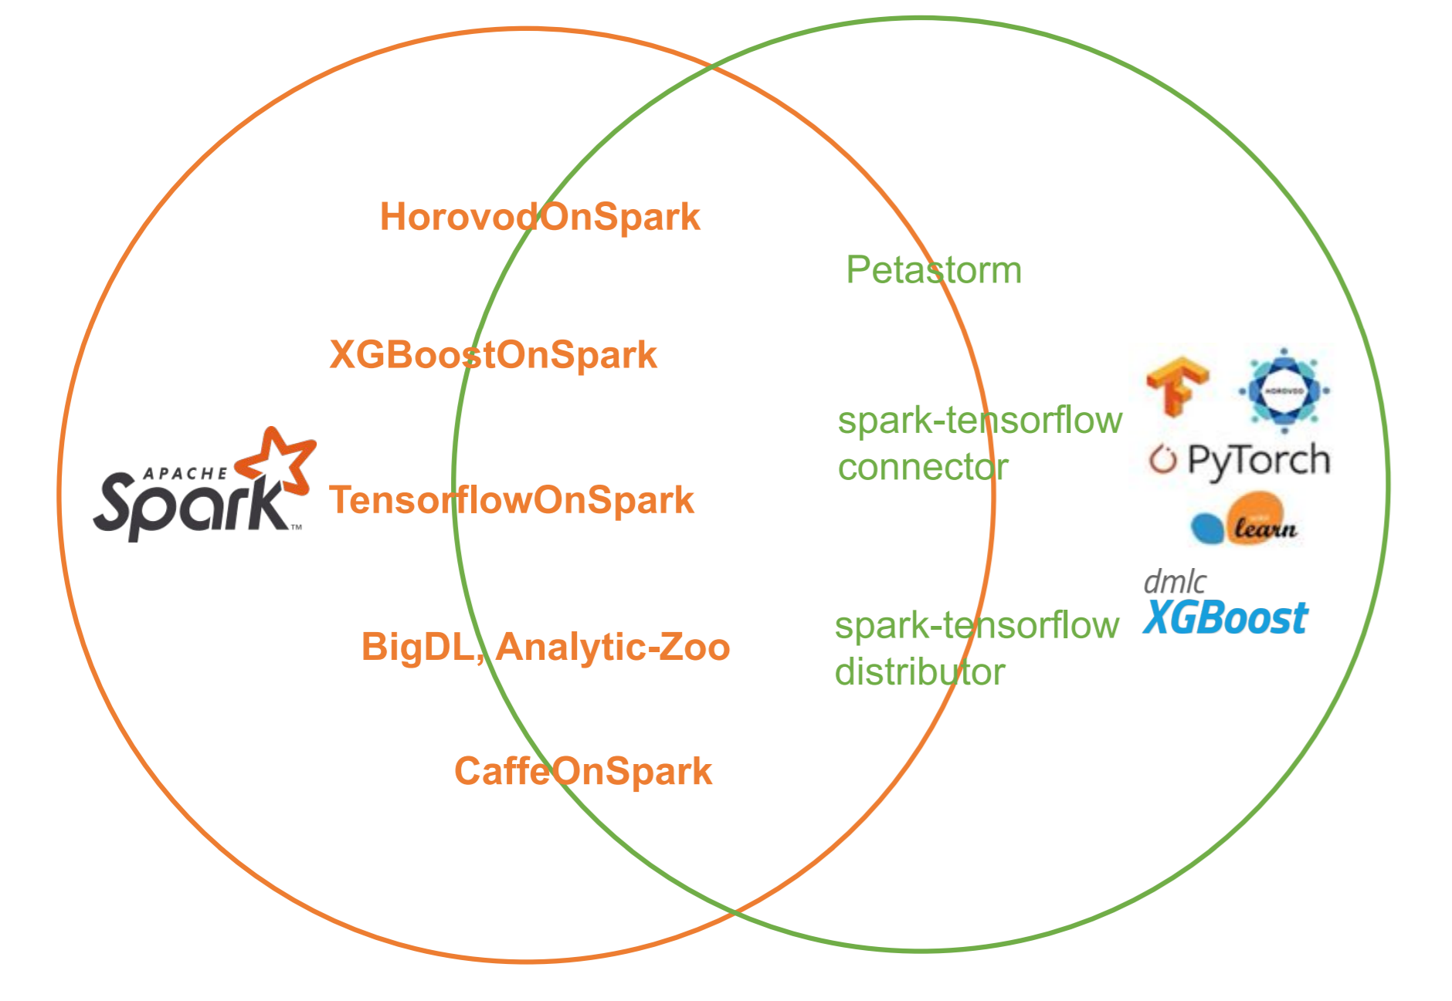

such as [spark-tensorflow-distributor](https://github.com/tensorflow/ecosystem/tree/master/spark/spark-tensorflow-distributor) is an open-source native package in TensorFlow that helps users do distributed training with TensorFlow on their Spark clusters. It is built on top of tensorflow.distribute.Strategy, which is one of the major features in TensorFlow 2 but it is a vendor lock-in choice and it had very bad performance when deal with quite big data processing as it did not leverage memory sharing mechanism and micro-scheduling optimization mentioned above between Spark data management and Tensorflow data management.

Maybe you might look at something like [Horovod](https://github.com/horovod/horovod) which is more , but Horovod is going to require you to fight against antiquated frameworks like MPI and wait a long time for compilation when you launch.Along with this complex setup, you’re going to need to give up the typical tools that you use, like Jupyter notebooks.

Although the Horovod community published Horovod on Spark **[6]** , there are still lots of performance challenges in real production adoption. DataFrames / RDDs not well-suited to deep learning (no random access) ,and challenges of Training on Large Datasets such as Sharding ,Streaming , Shuffling / Buffering / Caching and Data exchange between frameworks relies on distributed file systems like HDFS or S3.

***A takeaway of a good MLE platform to address those challenges is to leverage a distributed data processing library that provides simple APIs for running Spark and integrating Spark with distributed deep learning and machine learning frameworks which makes it simple to build distributed end-to-end data analytics and AI pipeline. Instead of using lots of glue code or an orchestration framework to stitch multiple distributed programs, it allows you to write Spark, PyTorch, Tensorflow, XGBoost code in a single python program with increased productivity and performance. You can build an end-to-end pipeline on a single cluster by using Spark for data preprocessing. Pay attention to optimize the data / memory sharing mechanism between Spark and DL framework and then better to leverage Framework-agnostic framework such as Horovod for distributed deep learning, and leverage AutoML frameworks (such as HyperOpt or Bayesian Optimization) for hyperparameter tuning.***

# 04 Model Deployment and Serving

The production maturity of serving and deployment of AI applications is still evolving, mainly because existing solutions are still not versatile and efficient enough.Support for model deployment is a necessary feature of the MLE platform .Let's focus on three important aspects that contribute to the model serving / deployment complexity of AI applications.

Algorithm Diversity

Even without counting the cutting-edge algorithms in academia, the types of algorithms and models used in the industry are extremely rich and diverse: machine learning model family, deep learning model family, hybrid integration model, operations research and optimization algorithm model, reinforcement learning model, graph network model, and so on.A good MLE platform should be “Algorithms Independent”, so that good business-level algorithms that have been successfully developed cannot be produced because the platform does not support them.  
  
A common solution to this problem in the industry is to simply encapsulate the algorithm model as a microservice, most often in the form of a Rest API to interact with the rest of the system components.But is that enough?

Resource Usage Characteristics

As for HTTP microservices, there is a huge difference between traditional web microservices and microservices that simply encapsulate the algorithm model in the underlying resource usage characteristics:

* Web microservices: The performance bottleneck is usually in I/O, i.e. waiting and blocking of network and database interactions, with low CPU computing load.Thus, typically a microserver process serving 10-10,000 requests is at a normal level.

And the logic is the same for each request, so load balancing is simple.

* ML model microservices: mainly numerical calculations.During the computation, the CPU load is close to 100%.Because of this, a microserver process can only service 10-100 requests.To make matters worse, if an exception occurs during computation, the entire microservice stops responding.For each request, different models may need to be accessed, and it is not feasible to load these models into memory at the same time due to hundreds of megabytes and gigabytes of memory size, which makes load balancing significantly more complex.

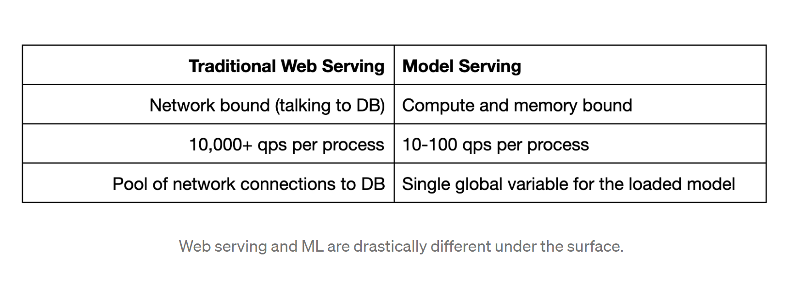**[7]**

Given these differences, it is clear that simply "embedding" models into microservices is not a sustainable solution.For this concern, industry leaders such as Google and Amazon have put forward their own solutions. What these solutions have in common is to separate the HTTP server of microservices from the model and build an independent computing cluster for the model calculation, which becomes the External microservice backend.However, this raises another issue that needs to be addressed: the universality of the microservices architecture.

Framework or Vendor Lock-in

The deployment of the model with an external microservice back end is a better solution, but one remaining issue needs to be addressed, which is versatility: as mentioned above, with the rapid evolution and updating of algorithms, a common external microservice backend without a machine learning/deep learning framework is attractive.For example, Google's Tensorflow Serving is an excellent external microservice backend.However, the backend forces the application to use Google's own Tensorflow deep learning framework, this becomes a barrier because the framework limits what can be done.

***So , a good MLE platform should use a single toolkit to serve everything from deep learning models built with frameworks like*** [***PyTorch***](https://docs.ray.io/en/latest/serve/tutorials/pytorch.html#serve-pytorch-tutorial)***,*** [***Tensorflow, and Keras***](https://docs.ray.io/en/latest/serve/tutorials/tensorflow.html#serve-tensorflow-tutorial)***, to*** [***Scikit-Learn***](https://docs.ray.io/en/latest/serve/tutorials/sklearn.html#serve-sklearn-tutorial) ***models, to arbitrary Python business logic.***

Vendor lock-in: AWS SageMaker and the other cloud providers offer hosted ML serving solutions that wrap your models and deploy them for you. In addition, these hosted solutions don’t have a unified API. ***A good MLE platform should be vendor neutral solutions that avoid cloud vendor lock-in.***

Training & serving divergence: There are other solutions that take a trained model and convert it to another format for serving, like ONNX, PMML, and NVIDIA TensorRT. But we want to serve their models in the same framework that was used for training to avoid unknown bugs.

# 05 Feature Engineering

Typical Feature Engineering Process

A typical feature engineering process includes :

* Feature computing: Based on the curation of datasets , this process supports the preprocessing steps resolving DQ issues for feature engineering (such as missing value filled in , outlier removal etc.. ) and all kinds of sampling , the computing statistical metrics such as the total amount and distribution of specific dimensions in multiple time periods, then adopt feature extraction , encoding, transformation processing to the final features.
* Feature publishing: This process supports mapping the records in the physical tables to feature objects, and writes the serialized results to KV storage for better serving performance.
* Feature serving: The process supports online reading of feature objects from KV storage, and the deserialized results are used for model serving.

The increase in business lines bring multi task feature serving requirements , and the increase in data volume, the traditional approach gradually exposed the following three deficiencies:

* The cost of feature iteration is high: the framework lacks configuration management, new features need to be changed on the offline side and the online side code at the same time when new features are launched, and the iteration cycle is long.
* Difficulty in feature reuse: Similar scenarios exist between different business lines of takeaway, which makes feature reuse possible, but the framework lacks good support for reuse capabilities, resulting in waste of resources and inability to fully utilize the value of features.
* Lack of platformization capabilities: The framework provides the underlying development capabilities for feature reading and writing, but lacks platformization tracking and management capabilities for the complete cycle of feature iteration.

Feature Store Solution

So , a unified feature store solution is a very popular approach to address those concerns.

For example , FEAST is a good open source feature store been adopted widely [8]

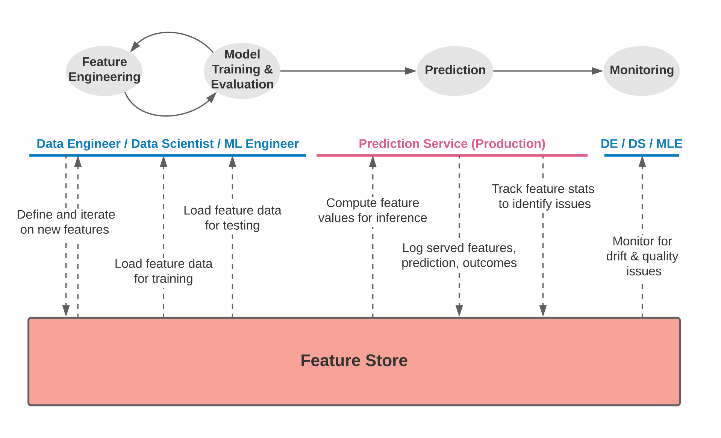

***Feature stores are systems that help to address some of the key challenges that ML teams face when productionizing features which should be a key takeaway of the MLE platform.***

* ***Feature sharing and reuse***: Engineering features is one of the most time consuming activities in building an end-to-end ML system, yet many teams continue to develop features in silos. This leads to a high amount of re-development and duplication of work across teams and projects.
* ***Serving features at scale***: Models need data that can come from a variety of sources, including event streams, data lakes, warehouses, or notebooks. ML teams need to be able to store and serve all these data sources to their models in a performant and reliable way. The challenge is scalably producing massive datasets of features for model training, and providing access to real-time feature data at low latency and high throughput in serving.
* ***Consistency between training and serving***: The separation between data scientists and engineering teams often lead to the re-development of feature transformations when moving from training to online serving. Inconsistencies that arise due to discrepancies between training and serving implementations frequently leads to a drop in model performance in production.
* ***Point-in-time correctness***: General purpose data systems are not built with ML use cases in mind and by extension don’t provide point-in-time correct lookups of feature data. Without a point-in-time correct view of data, models are trained on datasets that are not representative of what is found in production, leading to a drop in accuracy.
* ***Data quality and validation***: Features are business critical inputs to ML systems. Teams need to be confident in the quality of data that is served in production and need to be able to react when there is any drift in the underlying data

Although the feature store covers lots of problem statements ,in fact, there are still ML domain specific challenges which require specific enhanced solutions. Just take the search/recommendation system as one example.

The Embedding-based Retrieval Feature Engineering

Facebook published an impactable paper in 2020 which explored an embedding-based retrieval feature engineering innovations which optimized the search performance pretty well.

[Embedding-based Retrieval in Facebook Search](https://research.fb.com/wp-content/uploads/2020/08/Embedding-based-Retrieval-in-Facebook-Search.pdf) [9]

In this paper , Facebook introduced an unified embedding model that can incorporate various features other than text to improve the model performance. “We observed consistently across different verticals that unified embedding is more effective than text embedding. For example, there are +18% recall improvement when switching from text to unified embeddings for events search, and +16% recall improvement for groups search. The effectiveness of unified embeddings highly depends on the success of identifying and crafting informative features. Table 1 shows the incremental improvement by adding each new feature category to the group embedding model (with text features as baseline). In this section we discuss several important features that contributed to the major model improvements.”**[9]**

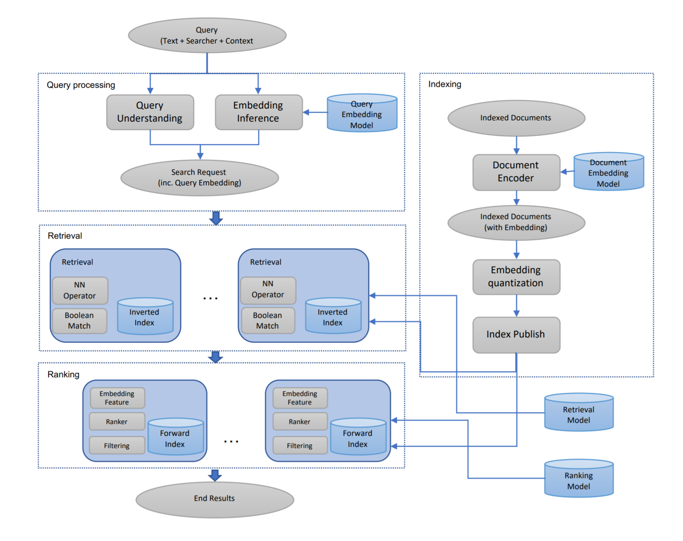

In Google [ICML 2020](https://icml.cc/Conferences/2020) paper, “[Accelerating Large-Scale Inference with Anisotropic Vector Quantization,”](https://arxiv.org/abs/1908.10396) Google addressed this similar problem by focusing on how to compress the dataset vectors to enable fast approximate distance computations, and propose a new compression technique that significantly boosts accuracy compared to prior works. This technique is utilized in their recently open-sourced [vector similarity search library](https://github.com/google-research/google-research/tree/master/scann) (ScaNN), and enables Google to outperform other vector similarity search libraries by a factor of two, as measured on [ann-benchmarks.com](http://ann-benchmarks.com/).

The Importance of Vector Similarity Search

Embedding-based search is a technique that is effective at answering queries that rely on semantic understanding rather than simple indexable properties. In this technique, machine learning models are trained to map the queries and database items to a common vector embedding space, such that the distance between embeddings carries semantic meaning, i.e., similar items are closer together.**[10]**



In our world , we did not have the similar search case but we did get inspiration from those great feature engineering ideas and re-engineered it to be a new feature store approach of our recommendation system ( based on User-Item propensity model) and achieved a very good boosting of performance metrics.

Here are the rough design ideas :  
Offline parts :

* Encode User features and Item features with normal feature engineering and load them into Redis KV.
* Train 2 Tower Model**[11]**  to generate User embedding and Item Embedding.
* Load the User embedding vectors into Redis KV and load Item embedding vectors into Faiss Index **[12]** at the beginning but we encountered scaled issue and challenges at deployment Faiss with K8S , so we changed the vector index and similarly search engine to Milvus**[13]** which is an open source vector similarity search engine, based on vector index libraries such as Faiss, NMSLIB, Annoy, etc. It is powerful, stable and reliable, and easy to use. Milvus integrates these vector index libraries and provides a set of simple and consistent API externally. In addition to providing near real-time search capabilities for vectors, Milvus can filter scalar data. With the increase of data and query scale, Milvus also provides a cluster sharding solution that supports functions such as read-write separation, horizontal expansion, and dynamic expansion, realizing support for ultra-large data scale.
* Develop a feature service( on Redis) and Recall service ( On Milvus)
* Train a Ranking Model ( not the focus in this topic) and develop a Ranking serving service

Online parts :

* Enhance the recommender service ( model serving ) to support embedding feature retrieval approach
* When real time serving request come with user Id , recommender service call Recall service which ask user embedding from feature service and generate TOP N ( N < =1000) item features based on vector similarity search with item embedding indexes
* Recommender service gets all user and pre-selected items features and call Ranking Serving service to get final TOP M ( M <=10) recommendation items

# 06 MLOps

MLOps includes lots of big topics. I would like to focus on the convergence between DataOps and MLOps which I think should be a key design consideration for the MLE platform.

**DataOps** is an automated, process-oriented methodology, used by analytic and data teams, to improve the quality and reduce the cycle time of data analytics.

**MLOps** is a practice for collaboration and communication between data scientists and operations professionals to help manage the production of ML lifecycle. MLOps looks to increase automation and improve the quality of production ML while also focusing on business and regulatory requirements.

To build an ML model, you need to go through a lot of mundane data management “data prep”: you have to clean and normalize the data for training; then, you transform it to deal with regulations (e.g., masking/anonymizing sensitive data), to make it easier to use (discretizing continuous variables into bins), and/or to come up with measurable quantities as columns describing the subjects of analysis (e.g., customers), stored in rows –this is called feature engineering.

Then, a data scientist creates a model. While model development differs from traditional programming, in the end, a model is nothing but code and must be managed as such: artifacts to produce the model are just source code that must be stored and versioned in a revision control tool. It must be tested, so that accuracy is high before they are deployed. Tests in ML are somewhat elaborate, as they typically include tuning hyperparameters and cross-validation. Finally, it should be monitored, so that the quality of the predictions is not compromised by a lack of quality in the data. There is also monitoring the accuracy of predictions, a subject we will come back to later.

These steps boil down to building the same kind of data pipelines as in traditional BI-style analytics (granted, some of the tools are different), and can be managed for faster delivery and better quality with the same DataOps methodology:

* Orchestrating data pipelines built with different tools,
* Managing several development environments using branch-and-merge revision control tools,
* Deploying analytics to production using infrastructure-as-code techniques (as in DevOps), and
* Automating tests that monitor quality both for the code (as in DevOps) and the data.

***So a takeaway of the MLE platform , simply MLOps and converge the same methodology as DataOps applied to ML models producing analytics, with an added capability to manage concept drift that makes sure the model remains accurate over time.***

# 07 PPML

Machine Learning (ML) and Deep Learning (DL) are increasingly important to many real-world applications. ML and DL models are first trained on known data and then deployed to interpret new data, including classifying images, and recommending content. In general, increased data results in a superior ML/DL

model. However, stockpiling vast amounts of data also conveys inherent privacy, security, and regulatory risks.

Privacy-Preserving Machine Learning (PPML)**[14]** helps address these risks. Using techniques such as cryptography, differential privacy, and hardware technologies, PPML aims to protect the privacy of sensitive user data and of the trained model as it performs ML tasks.

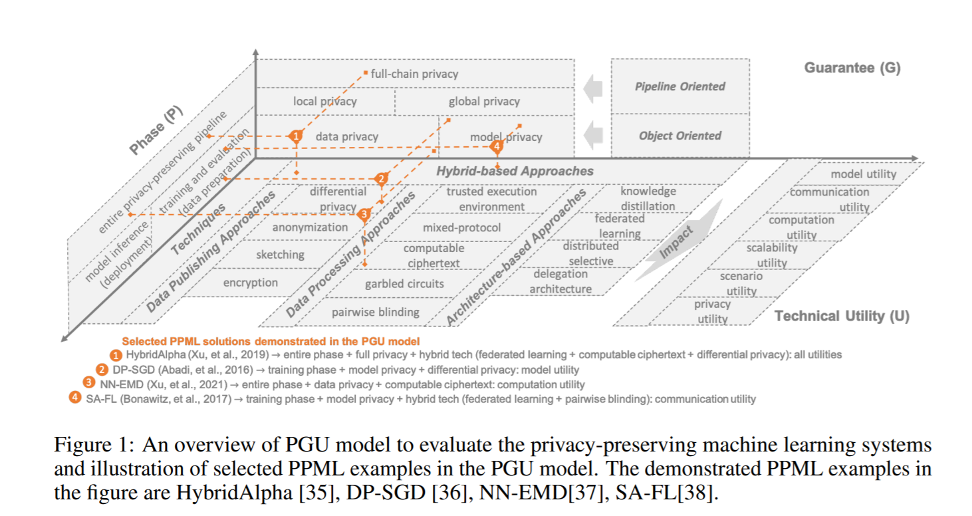

To simplify it , we can consider PPML as two major parts , data and software processing (software) and confidencial computing ( hardware).

For the confidencial computing part, take AKS confidential nodes for example which we already tried with a real production case.

AKS Confidential Nodes Features**[15]**

* Hardware based and process level container isolation through Intel SGX**[16]**  trusted execution environment (TEE)
* Heterogeneous node pool clusters (mix confidential and non-confidential node pools)
* Encrypted Page Cache (EPC) memory-based pod scheduling (requires add-on)
* Intel SGX DCAP driver pre-installed
* CPU consumption based horizontal pod autoscaling and cluster autoscaling
* Linux Containers support through Ubuntu 18.04 Gen 2 VM worker nodes

You can deploy distributed data processing like Spark on K8S and distributed training ( need a special library to turn on the SGX features) , tuning such as Ray , Horovod etc.. on top of those confidential nodes with K8S

# 08 Others

There are other factors in the MLE platform such as data labeling , model monitoring and maintenance etc.. which are also very critical for the whole lifecycle , due to the time of reading this article , I won’t break down them this time.

# Cite and references

1. **Machine Learning Engineering** written by [Andriy Burkov](https://www.linkedin.com/in/andriyburkov/).
2. <https://www.techrepublic.com/article/python-ends-c-and-javas-20-year-reign-atop-the-tiobe-index/>
3. <https://arrow.apache.org/docs/format/Columnar.html>
4. <https://arrow.apache.org/docs/python/plasma.html>
5. <https://towardsdatascience.com/apache-arrow-read-dataframe-with-zero-memory-69634092b1a>
6. <https://horovod.readthedocs.io/en/stable/spark_include.html>
7. <https://medium.com/distributed-computing-with-ray/machine-learning-serving-is-broken-f59aff2d607f>
8. <https://feast.dev/blog/what-is-a-feature-store/>
9. <https://research.fb.com/wp-content/uploads/2020/08/Embedding-based-Retrieval-in-Facebook-Search.pdf>
10. <https://ai.googleblog.com/2020/07/announcing-scann-efficient-vector.html>
11. <https://research.google/pubs/pub48840/>
12. <https://github.com/facebookresearch/faiss>
13. <https://milvus.io/>
14. <https://arxiv.org/abs/2108.04417>
15. <https://docs.microsoft.com/en-us/azure/confidential-computing/confidential-nodes-aks-overview>
16. <https://www.intel.com/content/www/us/en/architecture-and-technology/software-guard-extensions.html>